Ideation Phase

Define the Problem Statements

|  |  |
| --- | --- |
| Date | 18 June 2025 |
| Team ID | LTVIP2025TMID37335 |
| Project Name | pattern sense: classifying fabric patterns using deep learning |
| Maximum Marks | 2 Marks |

Customer Problem Statement Template:

I am a textile manufacturer, fashion designer, or fabric retailer who works with a large variety of fabric patterns.

I’m trying to efficiently and accurately classify fabric patterns into different design categories (such as floral, geometric, abstract, etc.) in order to automate inventory management, support design selection, and improve customer recommendations.

But the current manual process of inspecting and categorizing fabric patterns is slow, subjective, and requires skilled labor, leading to errors and inconsistencies.

Because there is no intelligent, automated system that can accurately recognize and classify fabric patterns from images at scale using advanced AI and deep learning methods.

Which makes me feel frustrated by inefficiency, limited in scaling operations, and unable to deliver personalized and modern experiences to customers.

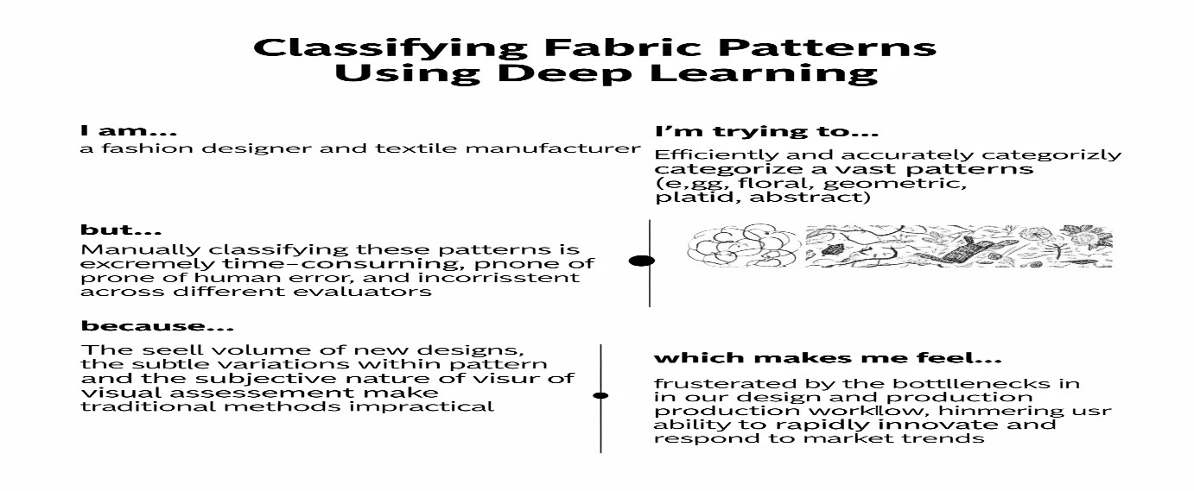

Problem

I am Which makes

Statement I’m trying to But Because

(Customer) me feel

(PS)

A textile Automate the Manual There is no AI- Frustrated,

PS-1

manufacturer classification of classification is based system limited in

Problem

|  |  |  |  |  |
| --- | --- | --- | --- | --- |
| I am  Statement  (Customer) | | I’m trying to But | | Which makes  Because me feel |
| (PS) |  |
|  |  | fabric patterns slow and | | capable of scalability, and accurately inefficient  recognizing and classifying complex fabric patterns |
| to improve inventory and production efficiency | inconsistent |
| PS-2 | A fashion retailer or designer | Recommend  designs to customers based on their pattern preferences | Current methods lack  precise, automated pattern categorization | There is no Unable to advanced provide  deep learning personalized  solution to experiences identify and  pattern types competitive reliably service |